Network Reconnaissance and Initial Security Assessment using nmap

1. Introduction
Network reconnaissance is an important initial phase of cybersecurity assessment. It involves gathering information about a target network, identifying active hosts, discovering open ports, and determining the services and technologies running on those hosts.

This project, titled Network Reconnaissance and Initial Security Assessment, was conducted in a controlled virtual laboratory using Kali Linux and Metasploitable 2.

Nmap was used to perform host discovery, TCP port scanning, service and version detection, operating system fingerprinting, and basic script-based checks.

The purpose of this project was to understand how network reconnaissance works in practice and identify potential security concerns associated with exposed network services.

All activities were performed within an isolated VirtualBox lab environment for educational purposes.

2. Project Objectives

The main objectives of this project are:

1. To understand the fundamentals of network reconnaissance.
2. To identify active hosts within a network.
3. To discover open TCP ports on a target machine.
4. To identify running services and their versions.
5. To perform basic operating system detection.
6. To use Nmap scripting capabilities for collecting additional service information.
7. To identify potential security weaknesses in exposed network services.
8. To recommend basic security improvements based on the observations.

Project Scope: The assessment is limited to the authorized VirtualBox laboratory network containing Kali Linux and Metasploitable 2.

3. Lab Environment and Tools Used

The project was performed using a virtual laboratory created with Oracle VirtualBox. Two virtual machines were configured to communicate through an isolated internal network.

3.1 Lab Environment

Component| Configuration
Virtualization Software| Oracle VirtualBox
Attacker Machine| Kali Linux
Target Machine| Metasploitable 2
Kali Internal IP| 192.168.56.10
Target IP| 192.168.56.20
Network Type| VirtualBox Internal Network
Network Range| 192.168.56.0/24

3.2 Tools Used

1. Kali Linux
Kali Linux was used as the testing platform to perform network reconnaissance and security assessment activities.

2. Metasploitable 2

Metasploitable 2 is an intentionally vulnerable Linux virtual machine used as the target for practical security testing and learning.

3. Nmap

Nmap (Network Mapper) is a network scanning tool used to discover hosts, identify open ports, detect services and versions, estimate operating systems, and perform basic script-based checks.

4. Oracle VirtualBox

Oracle VirtualBox was used to create and manage the virtual machines and configure the isolated laboratory network.

4. Network Architecture

The laboratory network was configured using Oracle VirtualBox with an isolated Internal Network.

Two virtual machines were connected through the same internal network:

- Kali Linux: Configured with IP address 192.168.56.10 on its internal network interface (eth1).
- Metasploitable 2: Configured with IP address 192.168.56.20 on its network interface (eth0).

Kali Linux also used a separate NAT adapter (eth0) for internet connectivity.

Both machines successfully communicated over the internal network, which was verified using the ping command.

The network configuration allowed reconnaissance activities to be performed safely within the 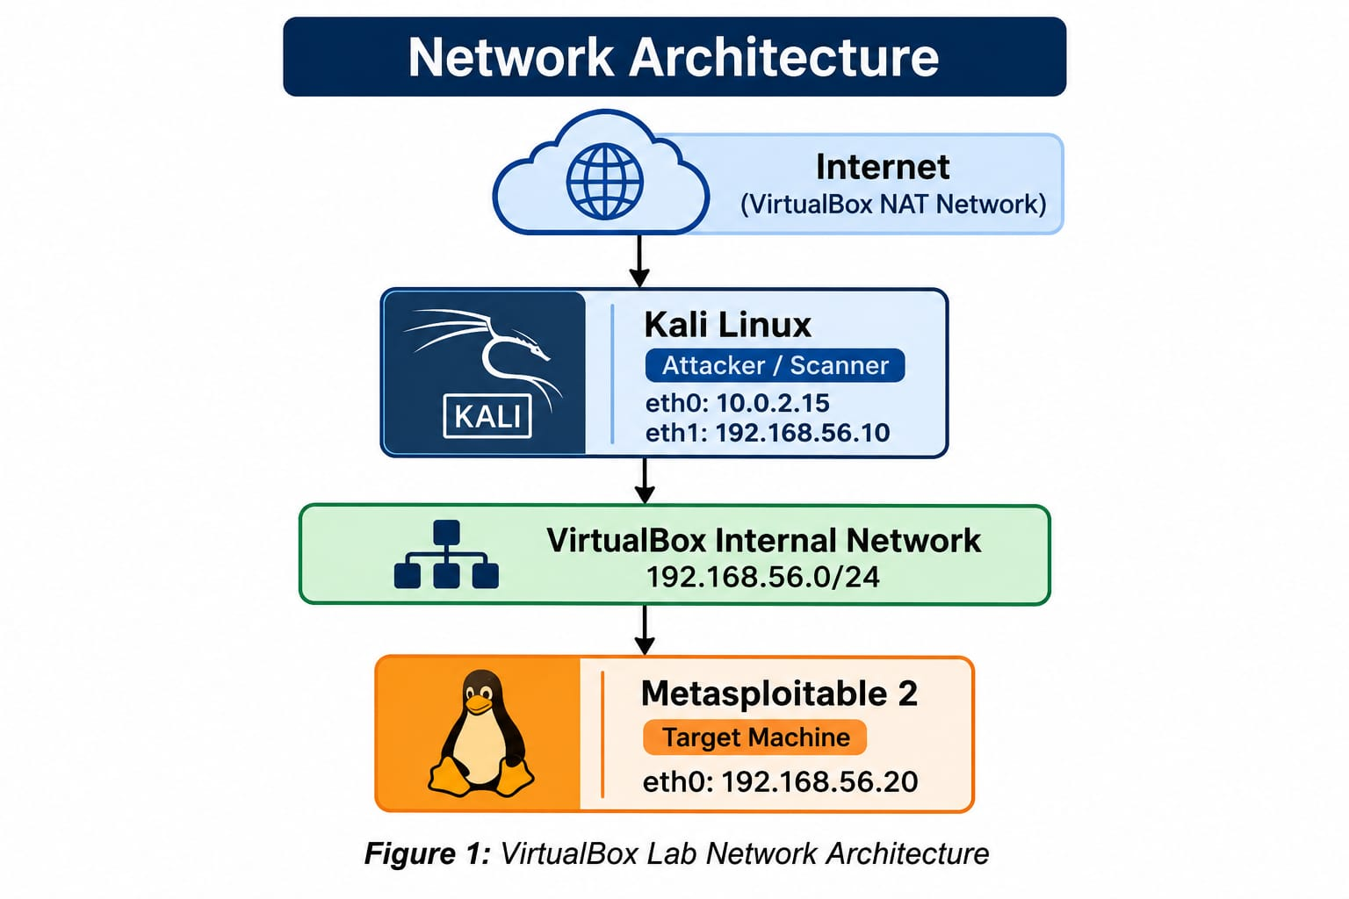controlled laboratory environment.
Figure 1: VirtualBox Lab Network Architecture
One correction to understand: Kali's eth0 connects to NAT, while eth1 connects to the internal lab network. The diagram shows both interfaces.
5. Methodology

The assessment followed a systematic network reconnaissance process using Nmap. Each stage was performed to collect specific information about the target machine.

5.1 Network Connectivity Verification

The ping command was used to verify communication between Kali Linux and Metasploitable 2.

Command:
"ping -c 4 192.168.56.20"

5.2 Host Discovery

Nmap host discovery was performed to identify active devices within the internal network.

Command:
"nmap -sn 192.168.56.0/24"

5.3 TCP SYN Scan

A TCP SYN scan was performed to examine the target machine's TCP ports.

Command:
"nmap -sS 192.168.56.20"

5.4 Service and Version Detection

Nmap service detection was used to identify the services and software versions running on the discovered ports.

Command:
"sudo nmap -sV 192.168.56.20"

5.5 Operating System Detection

Operating system detection was performed to estimate the operating system running on the target machine.

Command:
"sudo nmap -O 192.168.56.20"

5.6 Default NSE Script Scan

Nmap's default scripts were executed to collect additional information about the target's exposed services and configurations.

Command:
"sudo nmap -sC 192.168.56.20"

The results from these activities were reviewed to identify potential security concerns and document the observations.

6. Practical Implementation and Results

6.1 Network Connectivity Verification

The connectivity between Kali Linux and Metasploitable 2 was verified using the ping command.

Command:
"ping -c 4 192.168.56.20"

Observation:

The target machine successfully responded to all four ICMP echo requests. There was 0% packet loss, confirming network connectivity between the two virtual machines

6.2 Host Discovery

Nmap host discovery was performed to identify active devices within the internal network.

Command:
"nmap -sn 192.168.56.0/24"

Observation:

The scan identified two active hosts in the network. These corresponded to the Kali Linux machine and the Metasploitable 2 target.

Evidence: 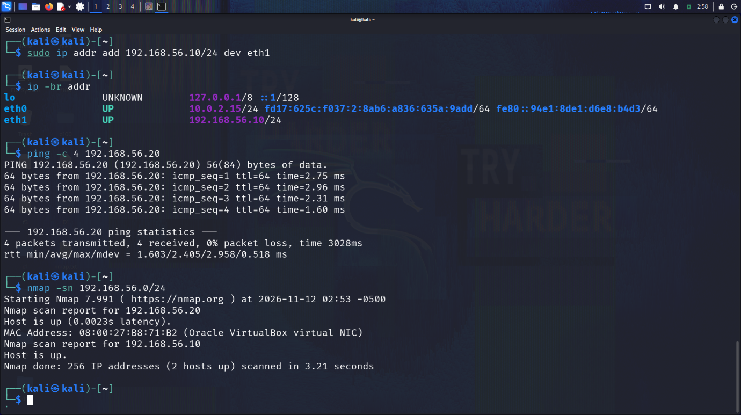

6.3 TCP SYN Scan

A TCP SYN scan was conducted to examine the target's TCP ports.

Command:
"nmap -sS 192.168.56.20”

Observation:

The initial scan displayed several ports as open|filtered. This result was ambiguous and did not independently confirm that those ports were open.

Further service detection scans were conducted to obtain more information.

Evidence: 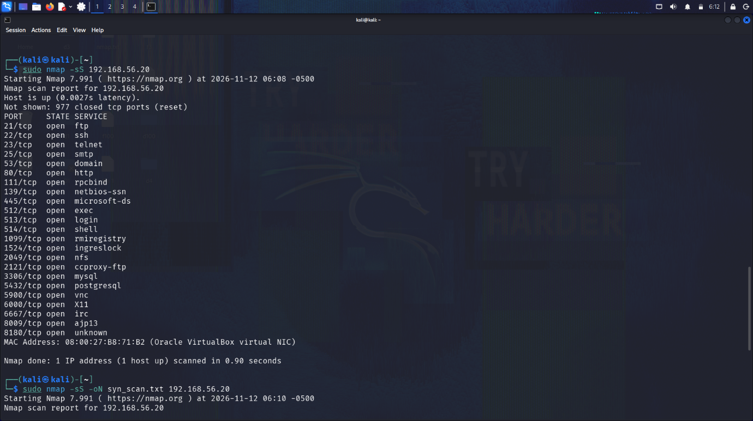

6.4 Service and Version Detection

Nmap service detection was used to identify services and their software versions.

Command:
"sudo nmap -sV 192.168.56.20"

Observation:

The scan identified 22 open TCP ports, including FTP, SSH, Telnet, SMTP, HTTP, SMB, MySQL, PostgreSQL and VNC.

Several services were identified as running older software versions.
Evidence: 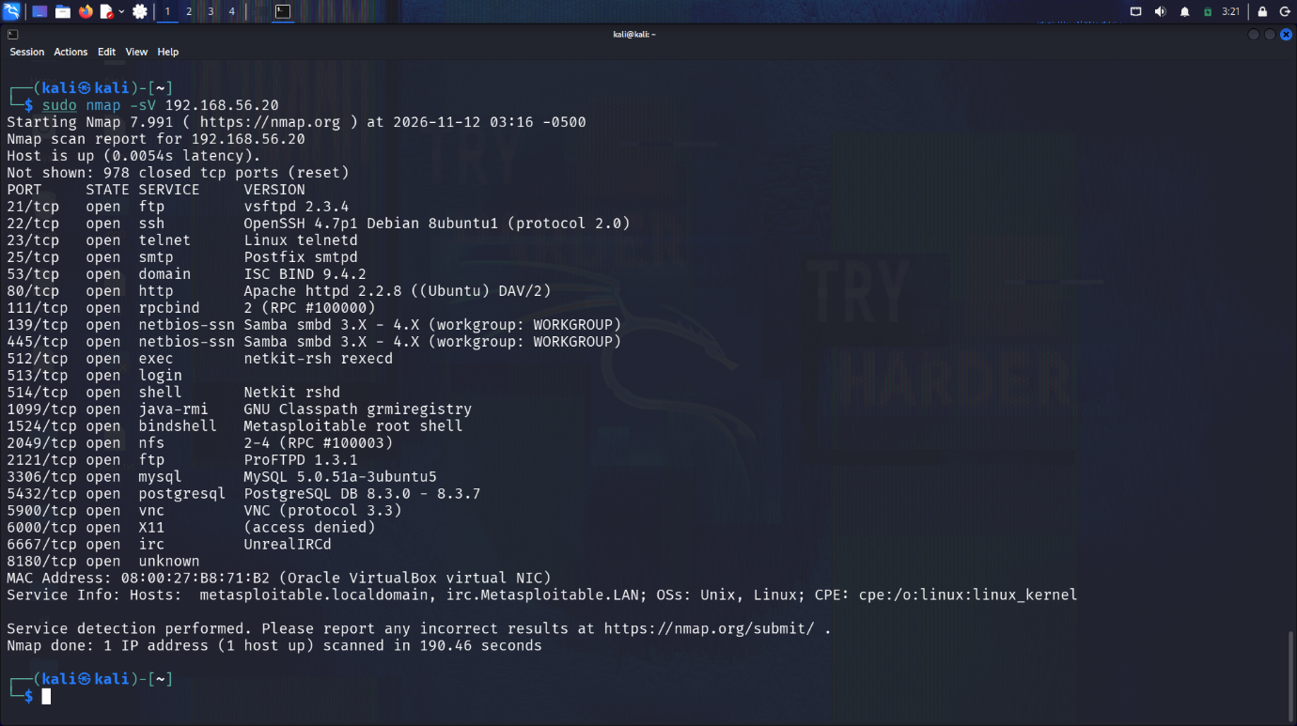

6.5 Operating System Detection

Nmap operating system detection was performed to estimate the target's operating system.

Command:
"sudo nmap -O 192.168.56.20"

Observation:

Nmap suggested that the target was likely running a Linux kernel from the 2.6 family. However, an exact operating system match was not obtained.

Evidence: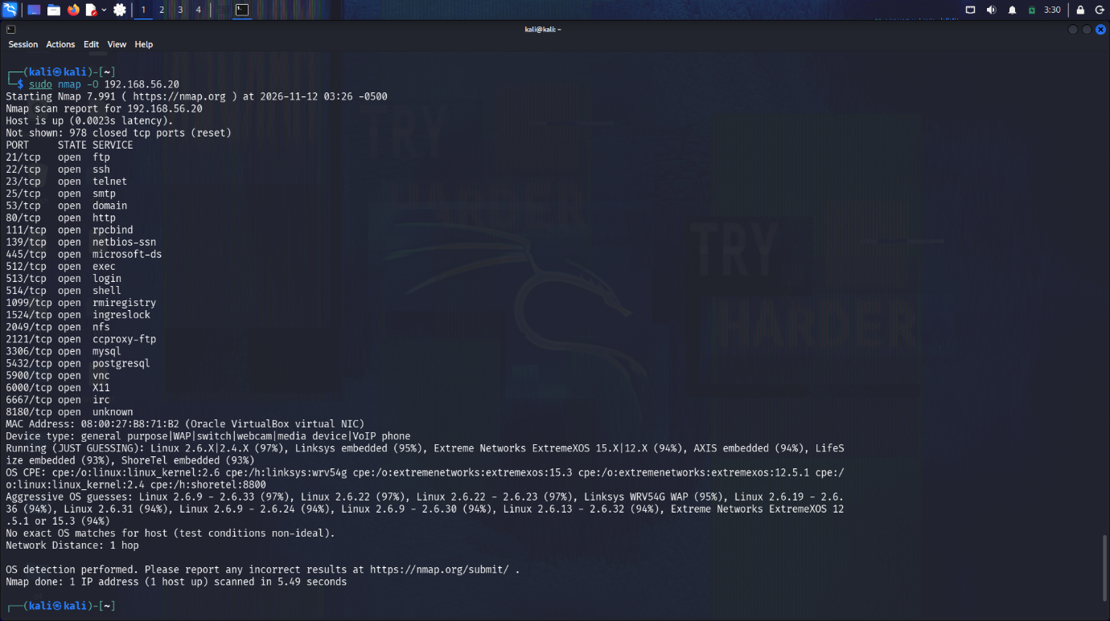

6.6 Default NSE Script Scan

Nmap default scripts were executed to collect additional information about the target's services.

Command:
"sudo nmap -sC 192.168.56.20"

Observation:

The scan revealed several security-relevant configurations and service details, including:

- Anonymous FTP login was permitted.
- SSLv2 support was detected on the SMTP service.
- SMB message signing was disabled.
- RPC and NFS service information was discovered.
- Additional details about SSH, MySQL, PostgreSQL and VNC were collected.

These observations were considered for further security analysis.

Evidence: 

